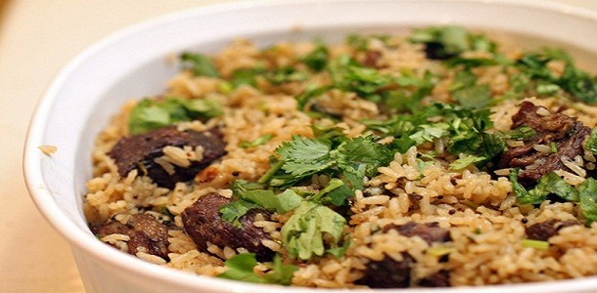

**Beef Pilau**

Ingredients:

* 1kg of rice
* 1kg of beef
* 40g pilau spices
* 250g butter
* 2 ltr vegetable stock
* 3tps.tomato paste
* salt to taste
* 4 piece crushed garlic
* 1 large onion

Preparation:

* Wash the beef then trim the excess fat .
* Cut the beef into large cubes and boil it for 15 minutes.
* Select the rice wash clean and strain out the water completely.
* In a shallow frying pan toss the pilau spice under low heat for 3minute then crush the spices using a food processor or blender till they are fine.

Method:

1. Sauté onion and crushed garlic in butter till golden brown.
2. Add the fine pilau spice ,allow to cook for a minute .
3. Add in the boiled beef then cook  while stirring.
4. Leave it for a while so as to absorb the spices.
5. Put the tomato paste.
6. Then add in the washed clean rice.
7. Stir gently so that the rice is well mixed with the beef and the spices.
8. Add in the vegetable stock.
9. Adjust the seasoning.
10. Leave  the food to simmer for 10minutes.
11. Reduce the heat when the food starts to cook so that it does not burn.
12. When the stock is almost dried up cover the food with a wet kitchen paper and a lid.
13. Cook till the dish is ready.
14. Garnish the pilau rice with chopped coriander.
15. Serve it hot with kachumbari which is a vegetable salad.

Note: Use of high quality rice gives the best results.Rice cooks faster than beef that is why it is advise able to boil the beef first.To Avoid chewing the hard pilau spices blending them is the best way to go,so that you have a fine dish that can be enjoyed by everyone in the family. Other type of this dish include mutton and chicken pilau.Kachumbari is the best side salad to serve with **beef pilau**.

Enjoy this recipe.

Inspired by [FoodReviewKenya](http://foodreviewkenya.com/674/simple-beef-pilau-recipe/)